  GIT & GITHUB | Abstract  Tutorial document that explains how to use Git and GitHub for version control.  James Bridge

How to set up a GIT repo
To start using GIT open CMD and navigate into your project directory. Use the git inti command to set up a git repository for the project. If successful you will get a message to say that the new repository has been initialized.

Staging Area
Git has a cache called a staging area. You need to push files to this staging area before they can be move along to the repo. You can check the status of your staging area with the git status command.
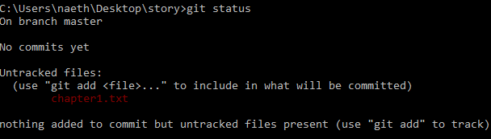
In the example above we can see that there are currently no files being tracked, no files in the staging area, and one file that is currently not tracked.
To add a file to the staging area we can use the command git add followed by the name of the file we wish to add to the staging area. If we then re-run the status command we will see the selected file showing up as being tracked with its name in green.
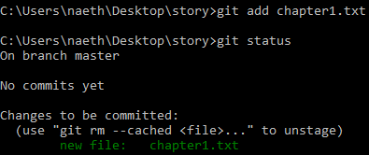

Commitments
Once you have a file in the staging area you can commit the file to the repo. When you do this it is important to add a commit message that explains what this commit contains. This way it is easy to track your save points and identify which one is needed in the event of a rollback.
To commit files in the staging area use the command git commit -m “your message here”.
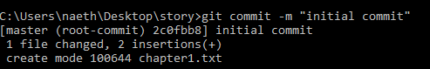
You can review which commitments have been made by using the git log command.
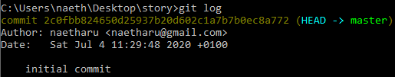
Note that the commit log contains a hash that uniquely identifies this commit. It also contains details of who made the commit, and the message that was logged.
If we want to add multiple new files to the staging area we can use the command git add . which will pick up all files in that folder and commit them at once.
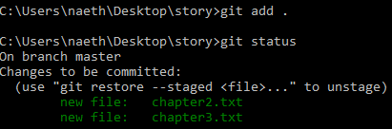
You can also commit more than one file at a time. When you run a commit command all files that are in the staging area will be added to the repo as part of that commit. In the case of our example we have both chapter2.txt and chapter3.txt added at the same time.
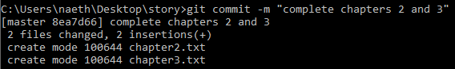

Going back to the git log command we can also see that we now have two distinct commits showing. Each has its own unique hash, and each has a specific commit message to explain what changes it contains.
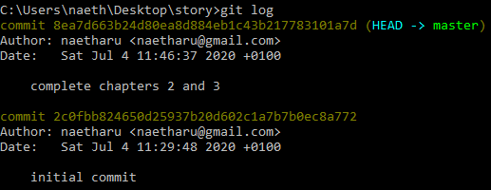

This graphic shows the directories we need to use:
The working directory is the local file on your machine where you save the files. The staging area is a cache that holds files that are to be uploaded to the local repo. The repo is where the actual commits are retained in order to maintain your version control.
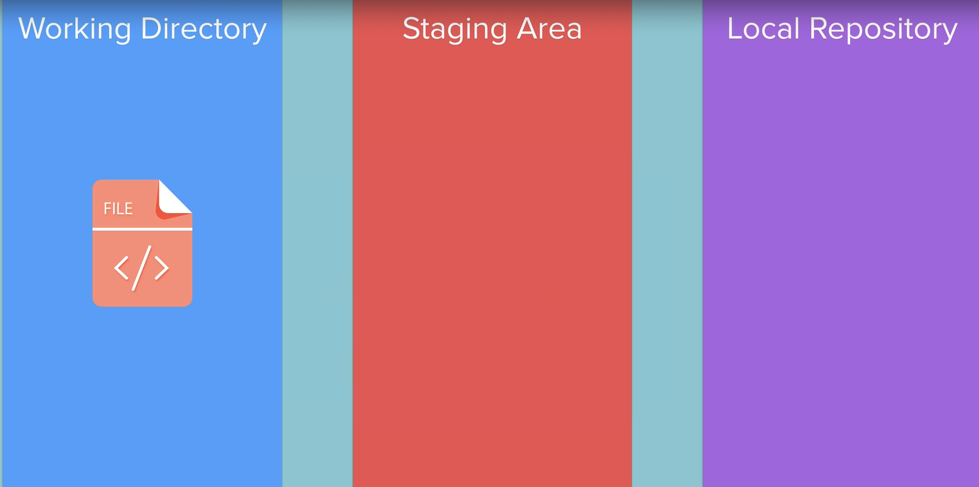
The purpose of the staging area is to allow us to choose which files we wish to be part of the repo. There are times where you may wish to keep specific files out of the repo. If they contain specific sensitive information then you may not wish to have them backed up in the repo. This is especially important when you proceed to backing up your git repos using online repositories like GIT-HUB.

Using GIT to roll back changes
Git allows us to roll back changes to our working files if we make changes that we need to revert. We can run the git status command to see that our working files are in a different state to the files in the repo commits. Here we can see the chapter2.txt file has been modified, and that the alterations have yet to be committed to the git repo.
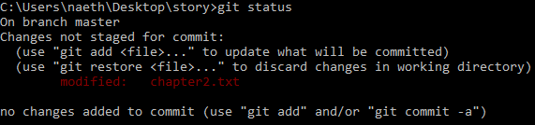
We can compare the current working directory file to the commit in the git repo by using the git diff <filename> command.
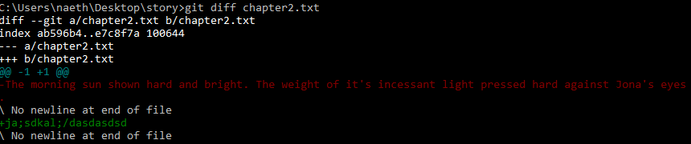
The parts of the file that are inside the commit but not in the local file are in red. The parts that are in the local file but not in the commit are in green.
To roll back to a previous version we can use the git checkout <filename> command. This will revert any changes and restore the local working file to be the same as the repo.

Using GitHub to back up your files
You can use GitHub as an online repository to back up all of your work. Start by navigating to https://github.com/ and creating an account. Once you have your account working click the + icon in the top right corner to create a new repository.
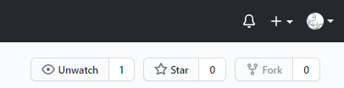
Give the repo a meaningful name, and a description so that you can easily identify it for future use. And then press Create.
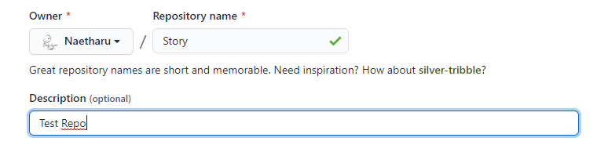
Next we need to link the local git repository with the online one at GitHub. We can do this by using the git remote add origin <repo URL> command.
This creates a remote connection between the two repos. We can now use a push command to upload the local repo to the remote one on GitHub. To do this we can use the following command: git push -u origin master.
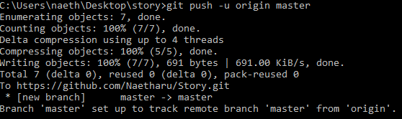

Retuning to your GitHub page you will now see the local files have been uploaded to the online remote repo.
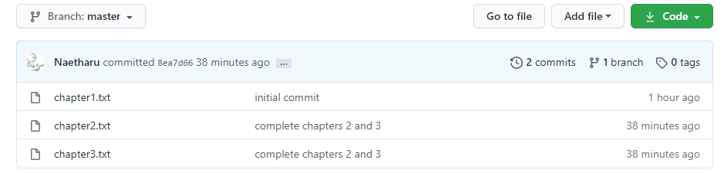
Looking in the insights graphs -> Network you can see a graphical representation of your commits.
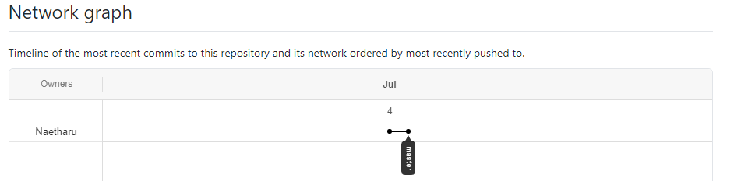
Our updated repo chart looks like this:
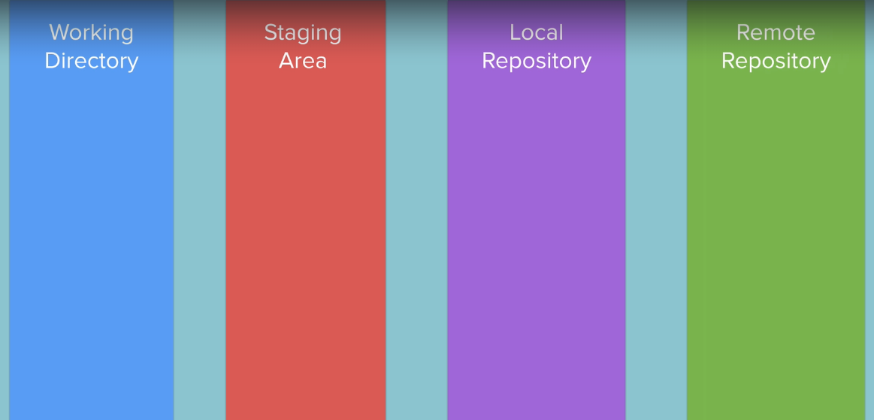

Git Ignore: How to avoid uploading sensitive data
You will not wish to commit all files. Some of your files may include sensitive such as passwords and API keys. You may also wish to avoid uploading files that are specific to local settings or user preferences. We can use git ignore in order to strip out files of this kind from git repositories.
Start by creating a file called gitignore at the root of your local working folder. Set this file to be hidden.
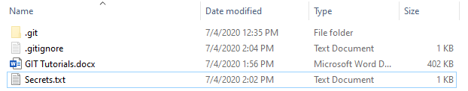
Open the file and add the names of any files you wish to be ignored by git. Make sure to name them exactly and include their extension.
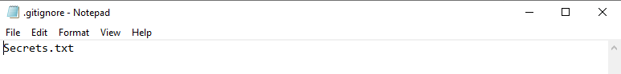
Now when we add our files to the staging area, we will no include any files that are listed here in the ignore file. In this case we can add our files and our sectrets.txt file will be left alone.
We can run a git add followed by a git status command and we get only our chosen files added. The secrets file is safely left alone.
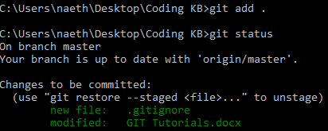
And likewise we can see that the secrets file is not uploaded to GitHub once we push our repo online.
